**Lecture 18**

**LVM4-Add-Extend-Remove-Logical Volume-Mappings**

**Example from practical (industry) work**

* 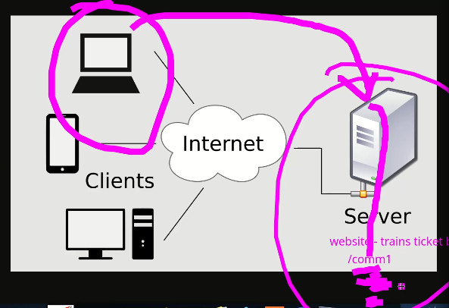
* In live scenario the /comm1 directory needs to be extended as per requirement, so LVM coms handy in this situation.
* So the partition is full
* 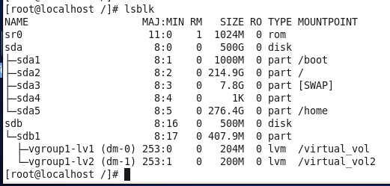
* But still 100 Mb “sdb1” --> how to add this space to LVM?
* The steps are,
* For this these are connected to eachoth,
* The unallocated 100Mb space needs another partition as /sdb2
* Explained in this snippet
* 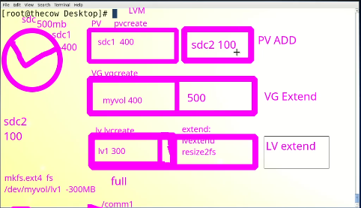
  + **Multiple PVs can be combined in VG**
  + **Similarly multiple LVs can also be combined in VG as shown in above mentioned snipet**
* Another partition is created from unallocate 100Mb in /dev/sdb
* /dev/sdb2
* Now,
* $ pvcreate /dev/sdb2 --> to add this 2nd partion in PV
* $ vgextend my_vol /dev/sdb2 --> to extend VG
* Then, $ lvextend –l %90free /dev/my_vol/lv1 --> newly acquired space is allocated to “lv1”
* $ resize2fs /dev/my_vol/lv1
* Lv1 is
* 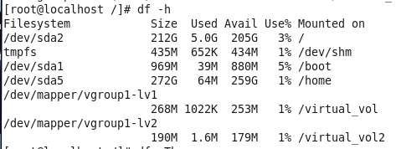
* At this point the whole space in this HDD is utilized...
* New task,
* A new HDD is required then utilized accordingly.
* The discover it by command
* $ echo “- - - ”
* Instead of a partition whole HDD can also be taken into LVM
* $ pvcreate /dev/<HDD_river>
* 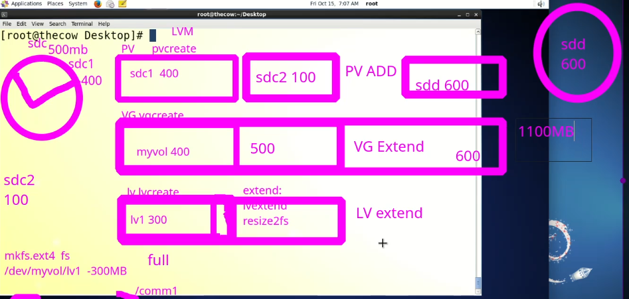
* Task make new /oracle --> 400 Mb
* In live industry example
  + A new HDD can be added
  + An existing LV partition
* Possibilities of LVM
* 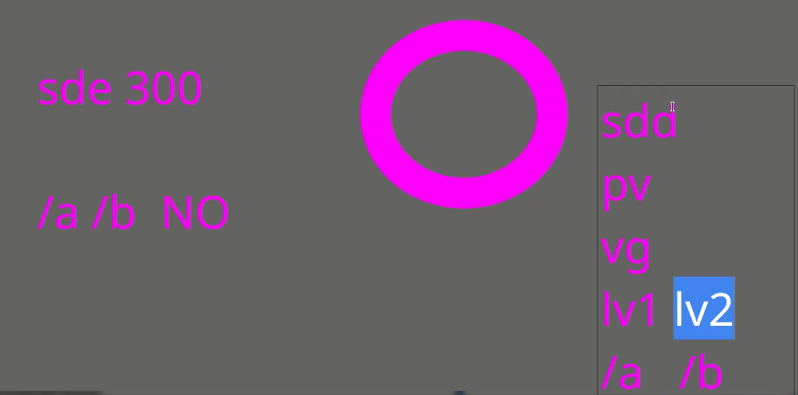
* There will be many PVs and LVs in production in industry
* How to know which HDD is mapped where?
* **How to find mappings in LVM?**
* $lsblk
* 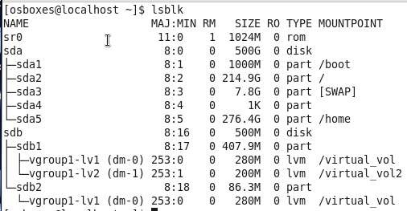
* There r more commands,
* $ lvs
* $ vgs
* $ pgs
* 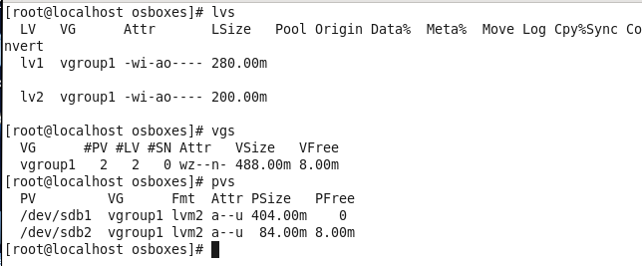
* $ pvscan
* $ vgscan
* $ mvsacn
* Another great command
* $ lvs -0 +devices
* 